A000-Asia-China-Qijia-Disk-3 Notch-Jade-3.2 in-2200 BCE

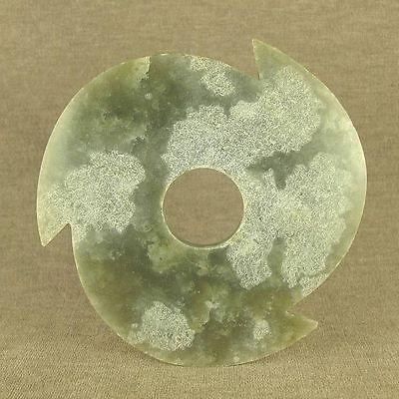 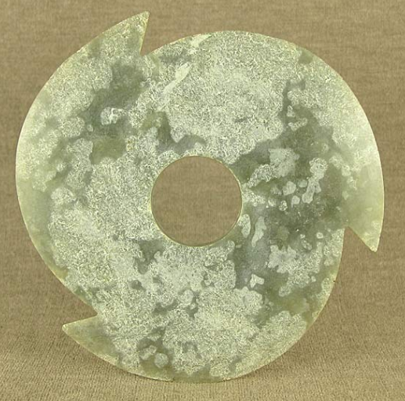

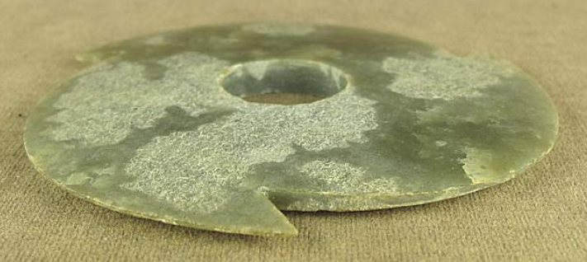

Figs. 1-3. Asia-China-Qijia-Disk-3 Notch-Jade-3.2 in-2200 BCE

**Case no.: 5**

**Accession Number:**

**Formal Label:** Asia-China-Qijia-Disk-3 Notch-Jade-3.2 in-2200 BCE

**Display Description:**

This Qijia Culture 齊家文化 Three-Notched Jade Disk ( Hsuan Chi ) dates approximately to the beginning of the Late Neolithic Xia Period,.2200 BCE. It is composed of silicates (antigorite, oltrelite, with iron schists), which provides a celadon green color. It has 3 notches without additional serrations, and its two sides are planar without any engravings. Its central hole is drilled from only one side. The notches may relate to the three major asterisms of the Little Dipper: Polaris, Alpha Ursae Minoris (alpha Mi) and, Kochab (beta UMi), and Pherkad (gamma UMi).

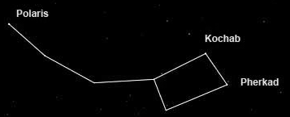

Fig. 4. The three major asterisms of the Little Dipper as they appear in the Southern Hemisphere after <https://www.space.com/28048-little-dipper.html>

**LC Classification:** NK5750.2.C6

**Date or Time Horizon:** 2200–1600 BCE

**Geographical Area:** Western Huang Ho region

**Map:**

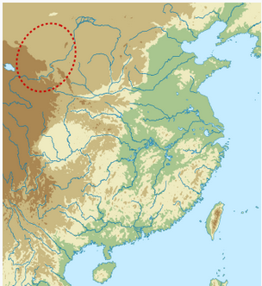

**Fig. 5. Location of the Qijia Culture after https://upload.wikimedia.org/wikipedia/commons/thumb/a/ac/Qijia_map.svg/330px-Qijia_map.svg.png**

**GPS coordinates:**

**Cultural Affiliation:** Qijia

**Medium:** green jade with some calcification

**Dimensions:** D 3.2 in, T 0.15 in

**Weight:**

**Condition: original.**

**Provenance:**

**Discussion: after Wikipedia.**

The **Qijia Bronze Age Culture** (2200–1600 BCE), was identified in 1923 by the Swedish archaeologist Johan Gunnar Andersson (1874–1960) in sites along the Tao River in Gansu province, but only in 1924 was it named after a site at Qijiaping, Guanghe county, Gansu. The jade artifacts from this culture are characterized by two major forms: the Bi or the Circular Disc that can also be notched and the Cong with its square, unadorned or ridged outer surface and hollow cylindrical inner core. Qijia jade Bi and Cong are mostly unadorned without engraved or modeled motifs. The two basic geometric forms of the Bi and Cong are the circle and the square, which, in associated cultures, especially the Liangzhu in the lower Yangtze area, are associated with Heaven and Earth respectively. The Qijia Culture did resume where the Majiayao Culture ended in 2200 BCE. a group of [neolithic](https://en.wikipedia.org/wiki/Neolithic) communities who lived primarily in the upper [Yellow River](https://en.wikipedia.org/wiki/Yellow_River) region in eastern [Gansu](https://en.wikipedia.org/wiki/Gansu), eastern [Qinghai](https://en.wikipedia.org/wiki/Qinghai) and northern [Sichuan](https://en.wikipedia.org/wiki/Sichuan), [China](https://en.wikipedia.org/wiki/China).[[1]](https://en.wikipedia.org/wiki/Majiayao_culture#cite_note-FOOTNOTELiuChen2012232-1) The culture existed from 3300 to 2000 BC. The Majiayao culture represents the first time that the Upper Yellow River region was widely occupied by agricultural communities and it is famous for its painted pottery, which is regarded as a peak of pottery manufacturing at that time. then it is possible to view some kind of cultural continuity with its preceding culture.

**References:**

Chen, Honghai. 2013. "The Qijia culture in the upper Yellow River valley". In Underhill, Anne P. A Companion to Chinese Archaeology. London: Blackwell, pp. 105–124.

Gu, Fang and Childs-Johnson, Elizabeth. 2008. *Jades of the Qijia and related northwestern cultures of early China, ca. 2100-1600 BCE* [project coordinator Jessica Curnoe]. New York: Throckmorton Fine Art